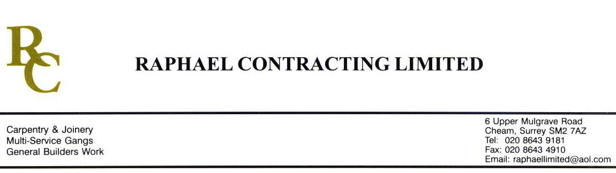

JMS JOINERY

ADDENDUM ORDER

Ref: ABERDEEN/ JMS 09

Date: 28/ 9/09

cc: Head Office

Dear Sirs,

Re: UNION SQUARE

Please find attached the information as listed below.

You are instructed to vary your work as appropriate in order to incorporate these details.

Would you please advise us within 7 days of any cost implications.

Yours faithfully,
MARK ROBINSON

For and on behalf of
Raphael Contracting Limited

Subject/Location Instruction/Enclosures.

PLEASE SUPPLY THE FOLLOWING UNITS, “GREENWICH WHITE” BY HOWDENS;-
MANAGEMENT SUITE, 1 x 1000mm BASE UNIT, 1 x 600mm BASE UNIT, 1 x 500mm BASE UNIT, 2 x 1000mm WALL UNITS. 1 x 2m WORKTOP, 1 x 3m WORKTOP. COLOUR T.B.C.
SHOPMOBILITY, 1 x 1000mm BASE UNIT WITH DRAW, 1 x 1000mm WALL UNIT. 1 x 2m WORKTOP COLOUR T.B.C.
CAR VALET, 1 x 1000mm BASE UNIT WITH DRAW, 1 x 1000mm WALL UNIT. 1 x 2m WORKTOP COLOUR T.B.C.
3 x ALUMINIUM WORKTOP JOINTERS

