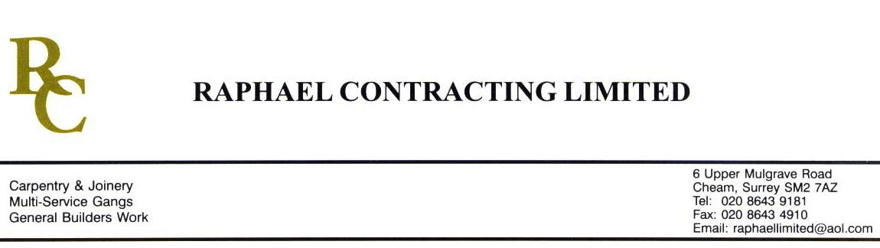

JMS

ADDENDUM ORDER

Ref: ABERDEEN/ JMS 11

Date: 29/ 9 /09

cc: Head Office

Dear Sirs,

Re: UNION SQUARE

Please find attached the information as listed below.

You are instructed to vary your work as appropriate in order to incorporate these details.

Would you please advise us within 7 days of any cost implications.

Yours faithfully,
MARK ROBINSON

For and on behalf of
Raphael Contracting Limited

Subject/Location Instruction/Enclosures.

PLEASE SUPPLY 1450 l/m HARDWOOD TROLLEY RAIL. OPTION 3. EX 150 x 25mm. PENCIL ROUND ON THE TOP AND BOTTOM OUTSIDE EDGES.

