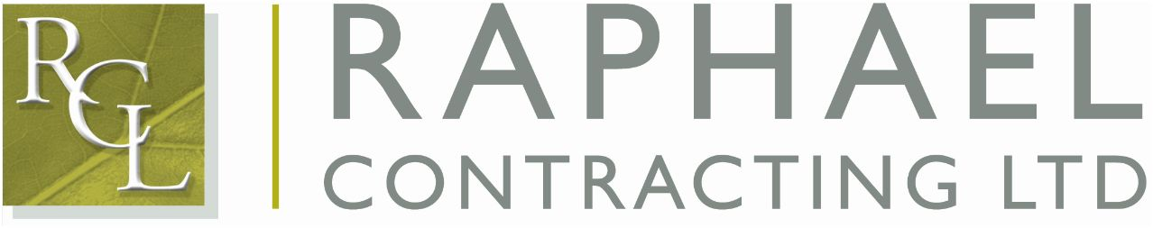
PURCHASE ORDER - No.

PURCHASE ORDER - No. 26417

DATE: 24-8-11 |  |  | CONTRACT: CHISWICK GREEN PROJECT (CHIS02)
TO:
HERTINGS

SITE DELIVERY ADDRESS: Raphael Contracting Ltd
c/o Bam Construction Ltd
610-624 Chiswick High Road
Chiswick
London
W4 5RX
TO THE BUYER: When ordering timber-based products please ensure the product meets at least one of the following criteria and tick the relevant box.
FSC  PEFC  BM TRADA 
TO THE TIMBER SUPPLIER: Please do not accept this order unless one of the above certifications has been ticked.
QUANTITY | DESCRIPTION |  |  |  |  |  | UNIT COST
10 pairs  1000  400  600  600  1000 | Gloves size 10  2x10 woodscrews  21/2x10 woodscrews  4x10 woodscrews  1x8 woodscrews  Brown plugs |  |  |  |  |  | Agreed prices
DATE REQUIRED BY:  Friday 02-09-11 |  |  |  |  | AUTHORISED BY: D Sanders

