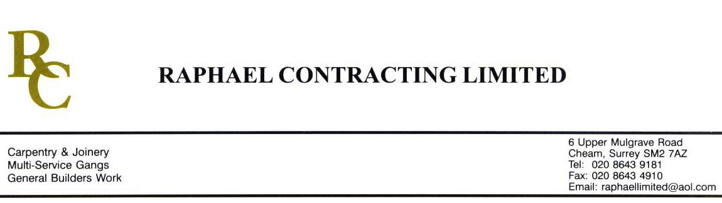

ALLIANCE WORKS

ADDENDUM ORDER

Ref: BRISTOL/ JMS 24 Date: 8 / 10 /08

cc: Head Office

Dear Sirs,

Re: CABOT CIRCUS

Please find attached the information as listed below.

You are instructed to vary your work as appropriate in order to incorporate these details.

Would you please advise us within 7 days of any cost implications.

Yours faithfully,
MARK ROBINSON

For and on behalf of
Raphael Contracting Limited

Subject/Location Instruction/Enclosures

PLEASE SUPPLY THE FOLLOWING DOORS AND FRAMES ONLY;- 2 x TYPE J4 DOOR SETS, 1 x D3 DOOR SET AND 23 No 50 x 18mm MDF ARCHITRAVES ( 2.4 long ). ALL THE ABOVE TO BE PRIMED FOR PAINT FINISH.

