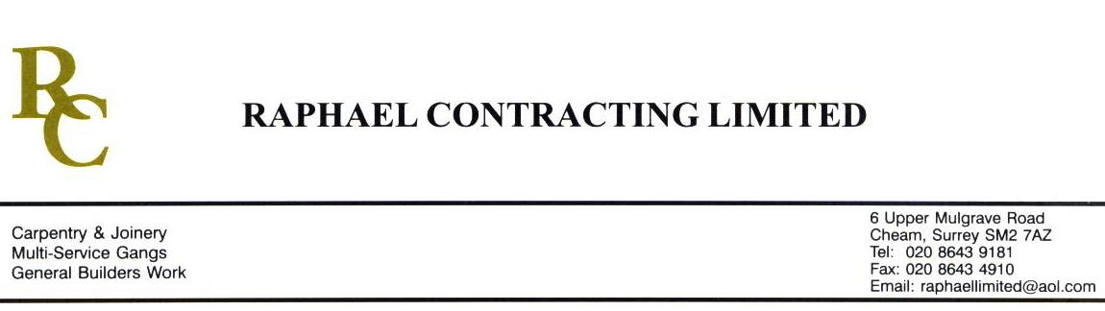

BRISTOL ALLIANCE - DIRECT

ADDENDUM ORDER

Ref: BRISTOL/ JMS 23 Date: 3 / 10 /08

cc: Head Office

Dear Sirs,

Re: CABOT CIRCUS

Please find attached the information as listed below.

You are instructed to vary your work as appropriate in order to incorporate these details.

Would you please advise us within 7 days of any cost implications.

Yours faithfully,
MARK ROBINSON

For and on behalf of
Raphael Contracting Limited

Subject/Location Instruction/Enclosures
PLEASE SUPPLY THE FOLLOWING ;-

1. 7 No PLANTERS,
2. 9 No BENCH’S,
3. 60 L/M 140 x 18mm PROFILED OAK,
4. 1 EXTRA PLINTH
5. RETURN TO SITE OF 44 x 10mm OAK SLATS ( 500 L/M )
6. 8 No IROKO SEATS 550 x 500 x 50mm c/w 10M 75 x 50 BEARERS
7. 8 No IROKO SEATS 1000 x 500 x 50mm c/w 10M 75 x 50 BEARERS.
8. ALL PAINTED MDF SCREENS FOR SU19.
9. 2 No OAK LOUVRES 1605 x 1000mm

