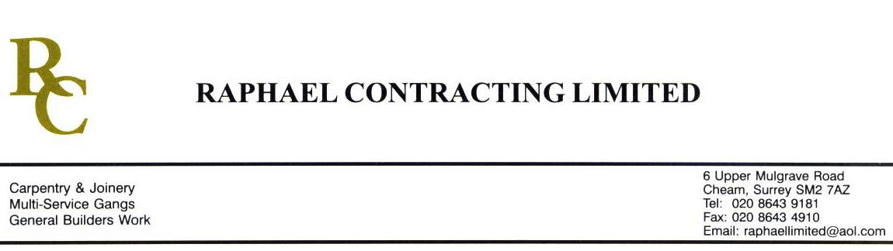

TIMBMET

ADDENDUM ORDER

Ref: BRISTOL/ TIMB/ JMS 16 Date: 27 / 6 /08

cc: Head Office

Dear Sirs,

Re: CABOT CIRCUS

Please find attached the information as listed below.

You are instructed to vary your work as appropriate in order to incorporate these details.

Would you please advise us within 7 days of any cost implications.

Yours faithfully,
MARK ROBINSON

For and on behalf of
Raphael Contracting Limited

Subject/Location Instruction/Enclosures

PLEASE SUPPLY 50 L/M 100mm x 20mm SQUARE EDGED OAK, PRIME GRADE. AND 10m x 75 x 38mm SQUARE EDGED OAK.

THIS IS TO BE DELIVERED TO JMS JOINERY TO BE MACHINED THEN DELIVERED TO BRISTOL.

