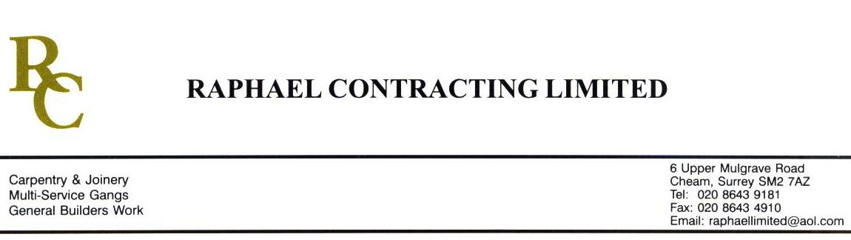

ACROPOLIS

ADDENDUM ORDER

Ref: GLOUCESTER/ACROP 103 Date: 6/ 5 /09

cc: Head Office

Dear Sirs,

Re: GLOUCESTER QUAYS

Please find attached the information as listed below.

You are instructed to vary your work as appropriate in order to incorporate these details.

Would you please advise us within 7 days of any cost implications.

Yours faithfully,
MARK ROBINSON

For and on behalf of
Raphael Contracting Limited

Subject/Location Instruction/Enclosures.

F.O.C.
1, PLEASE CARRY OUT 20mm APROX LATEX BUILD UP ( APROX 4m2 ) TO LEVEL IN WITH 1:6 RAMP AND 1:6 PUBLIC TOILETS.
2, LATEX AROUND THE 3 DOUBLE DOORS LAEDING IN TO THE ATRIUM FLOOR ON LEVEL 1. SLOPE TO BE 1:20.
PILLAR & LUCY
LATEX RAMP IN FRONT OF LIFT DOORS ON LEVELS 1, 2 & 3 TO FINISH CARPET UNDER THE LIFT THRESHOLD. 18mm – 0mm

