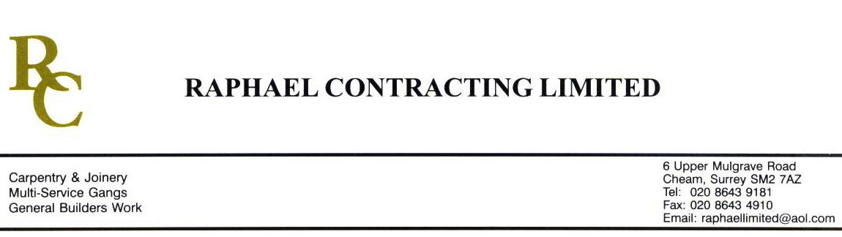

ACROPILIS

ADDENDUM ORDER

Ref: GLOUCESTER/ACROP 121 Date: 27/ 5 /09

cc: Head Office

Dear Sirs,

Re: GLOUCESTER QUAYS

Please find attached the information as listed below.

You are instructed to vary your work as appropriate in order to incorporate these details.

Would you please advise us within 7 days of any cost implications.

Yours faithfully,
MARK ROBINSON

For and on behalf of
Raphael Contracting Limited

Subject/Location Instruction/Enclosures.

PLEASE SUPPLY 1 BOX OF THE FOLLOWING TO BE STORED AS SPARES BY THE CLIENT ;-
- ‘HEUGA’ 500 x 500 CARPET TILES. COLOUR 345 MOON RIVER. (P&L)
- ‘DESSO’ 500 x 500 MENDA CARPET TILES, A454 9504/ DARK GREY. (M / SUITE)
- ‘BURMATEX’ BROADWAY 4400, OREGON GREY 11502. (M / SUITE)
- SMALL ROLL TARKETT SAFETREAD, BESSEMER 3821410. (M / S)
- SMALL ROLL TARKETT ECLIPSE PREMIUM, GREY 3440012. (M / S)
BLLI-17703

