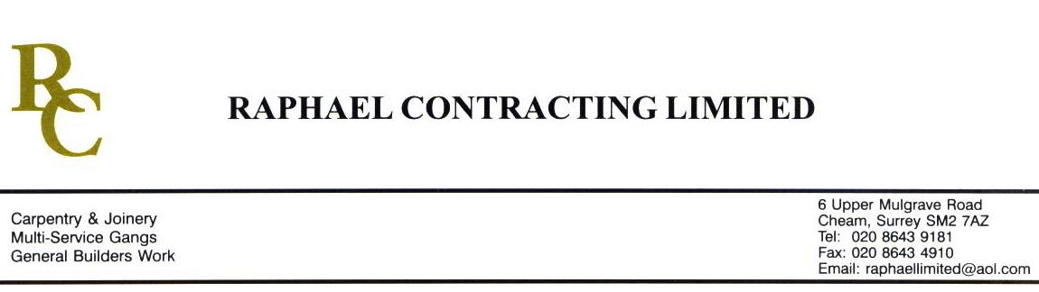

ACROPOLIS FLOORING

ADDENDUM ORDER

Ref: GLOUCESTER/ACROP 50 Date: 17/ 2 /09

cc: Head Office

Dear Sirs,

Re: GLOUCESTER QUAYS

Please find attached the information as listed below.

You are instructed to vary your work as appropriate in order to incorporate these details.

Would you please advise us within 7 days of any cost implications.

Yours faithfully,
MARK ROBINSON

For and on behalf of
Raphael Contracting Limited

Subject/Location Instruction/Enclosures
FOC PILLAR & LUCY
DY(20)1O-1-001 REV 07 DY(20)7- -0-502 REV 01
1N-1-001 REV 08 1-503 REV 04
1P -1-001 REV 08 2-504 REV 04
1K-1-001 REV 12 3-505 REV04
DY(74)1- -1-007 REV 07 4-506 REV 01
M50 SPECIFICATION DY(99)7- -99-043 REV 00
FOC FINISHS SCHEDULE P & L FINISHS SCHEDULE

