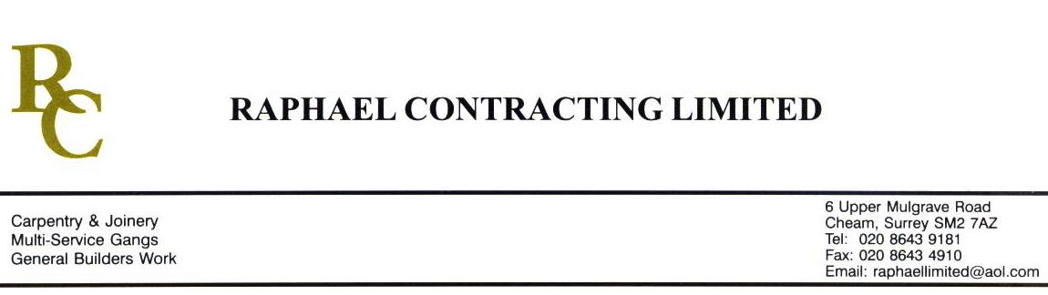

ACROPOLIS

ADDENDUM ORDER

Ref: GLOUCESTER/ ACROP 76 Date: 1/ 4 /09

cc: Head Office

Dear Sirs,

Re: GLOUCESTER QUAYS

Please find attached the information as listed below.

You are instructed to vary your work as appropriate in order to incorporate these details.

Would you please advise us within 7 days of any cost implications.

Yours faithfully,
MARK ROBINSON

For and on behalf of
Raphael Contracting Limited

Subject/Location Instruction/Enclosures.

- HIGH BUILD / LATEX IN THE SHOPMOBILITY TO LEVEL IN WITH CHIPBOARD FLOORING AND CONCRETE. ALSO LEVEL OUT DIP IN FLOOR.
- SUPPLY 3 FITTERS TO WORK IN CORRIDOR OF ZONE 2 FITTING VINYL SATURDAY & SUNDAY 4th & 5th APRIL.

