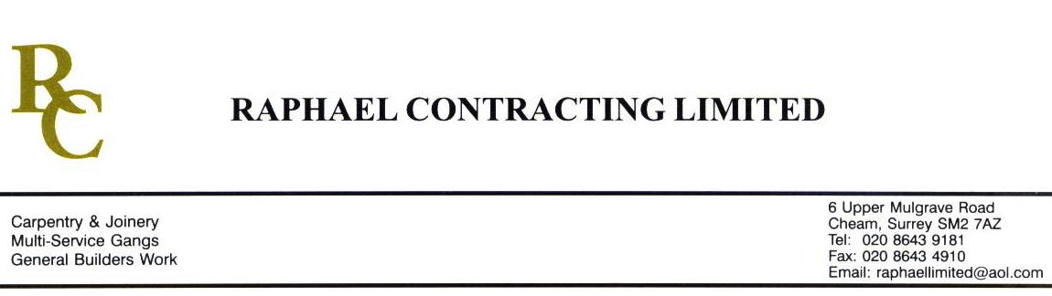

ACROPILIS FLOORING

ADDENDUM ORDER

Ref: BRISTOL/ ACROP 33 Date: 18/ 3 /09

cc: Head Office

Dear Sirs,

Re: CABOT CIRCUS – DIRECT WORKS 04

Please find attached the information as listed below.

You are instructed to vary your work as appropriate in order to incorporate these details.

Would you please advise us within 7 days of any cost implications.

Yours faithfully,
MARK ROBINSON

For and on behalf of
Raphael Contracting Limited

Subject/Location Instruction/Enclosures

- PLEASE SUPPLY AND FIT 50oz, TOM KINGSTON TWIST CARPET 80/20 TO FLAT 2:03, BLOCK 10 £320.
- PLEASE SUPPLY AND FIT THE ABOVE TO FLAT 2:20, BLOCK 9. AREA TO BE COVERED 4.5 x 3.5m

