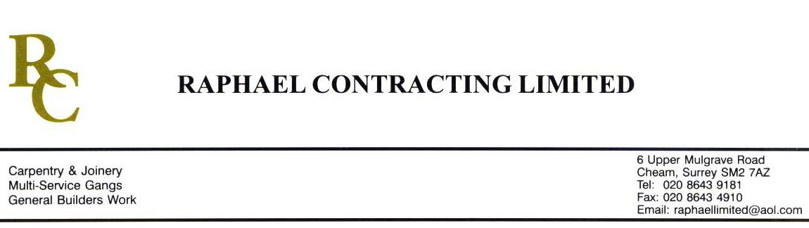

AMWELL

ADDENDUM ORDER

Ref: GLOUCESTER/ AMWL 06 Date: 14 / 12 /08

cc: Head Office

Dear Sirs,

Re: GLOUCESTER QUAYS

Please find attached the information as listed below.

You are instructed to vary your work as appropriate in order to incorporate these details.

Would you please advise us within 7 days of any cost implications.

Yours faithfully,
MARK ROBINSON

For and on behalf of
Raphael Contracting Limited

Subject/Location Instruction/Enclosures

PILLAR & LUCY DRAWINGS;- DY(74)7- -99-501 REV 01
“ “ 502 REV 01
“ “ 504 REV 00
“ “ 505 REV 00
“ “ 507 REV 00
“ “ 508 REV 00
“ “ 510 REV 01

