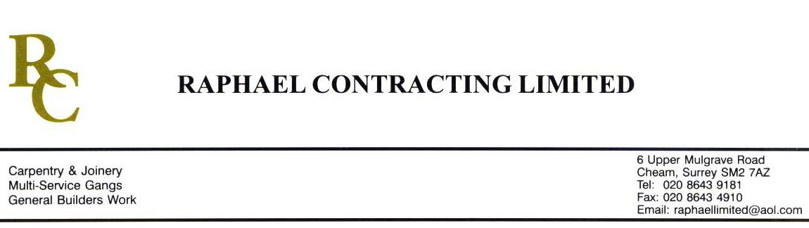

ASPEX

ADDENDUM ORDER

Ref: GLOUCESTER/ASPEX 119 Date: 26/ 5 /09

cc: Head Office

Dear Sirs,

Re: GLOUCESTER QUAYS

Please find attached the information as listed below.

You are instructed to vary your work as appropriate in order to incorporate these details.

Would you please advise us within 7 days of any cost implications.

Yours faithfully,
MARK ROBINSON

For and on behalf of
Raphael Contracting Limited

Subject/Location Instruction/Enclosures.

PLEASE SUPPLY THE FOLLOWING IRONMONGERY FOR THE F.O.C.

-1 PAIR LEVER HANDLES.
- 2 No 480mm x 80mm S/S PUSH PLATES
- 1 PAIR ESCUTCHEONS
- 2 No 425mm S/S PULL HANDLES
- 4 CYLINDERS c/w THUMB TURN FOR DOOR SETS FOC-01-121a, FOC-02-006a, FOC-03-007a AND FOC-04-005a NOTE THIS IS DUE TO THESES DOORS BEING CHANGED FD120S (64mm THICK).

