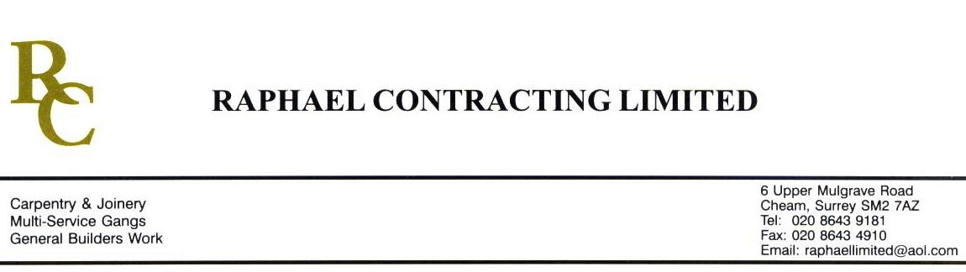

DYSON BRIGGS

ADDENDUM ORDER

Ref: GLOUCESTER/DYSON 44 Date: 6/ 2 /09

cc: Head Office

Dear Sirs,

Re: GLOUCESTER QUAYS

Please find attached the information as listed below.

You are instructed to vary your work as appropriate in order to incorporate these details.

Would you please advise us within 7 days of any cost implications.

Yours faithfully,
MARK ROBINSON

For and on behalf of
Raphael Contracting Limited

Subject/Location Instruction/Enclosures

FINISHS SCHEDULE ; - Rev 03

PILLAR & LUCY DRAWINGS ;-DY(74)7- -99-501 Rev 01 DY(22)7- -1-503 Rev 03
- “ 01 2-504 “ 03
- “ 01 3-505 “ 03
- “ 00 4-506 “ 00
- “ 00
- “ 00
- “ 00
- “ 00
- “ 01
- “ 01

