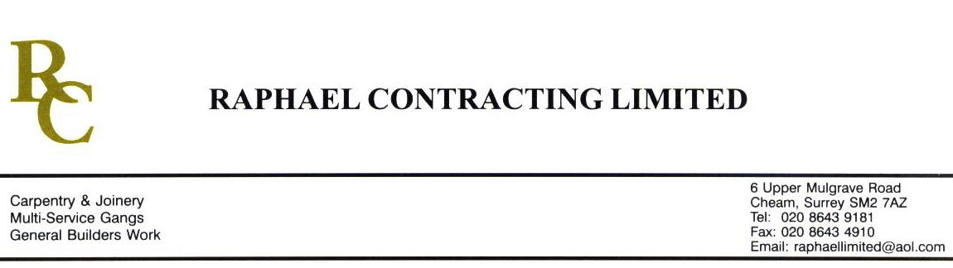

JMS JOINERY

ADDENDUM ORDER

Ref: GLOUCESTER/ JMS 100 Date: 30/ 4 /09

cc: Head Office

Dear Sirs,

Re: GLOUCESTER QUAYS

Please find attached the information as listed below.

You are instructed to vary your work as appropriate in order to incorporate these details.

Would you please advise us within 7 days of any cost implications.

Yours faithfully,
MARK ROBINSON

For and on behalf of
Raphael Contracting Limited

Subject/Location Instruction/Enclosures.

PLEASE SUPPLY THE FOLLOWING ; -

SHELVES, WHITE LAMINATE BOTH SIDES, 20 x 23mm H/WOOD LIPPINGS ALL ROUND, ROUNDED ARRISS. 18 No 400 x 200 x 20mm AND 3 No 500 x 200 x 20mm. 2 No PPC SHELF BRACKETS PER SHELF.

