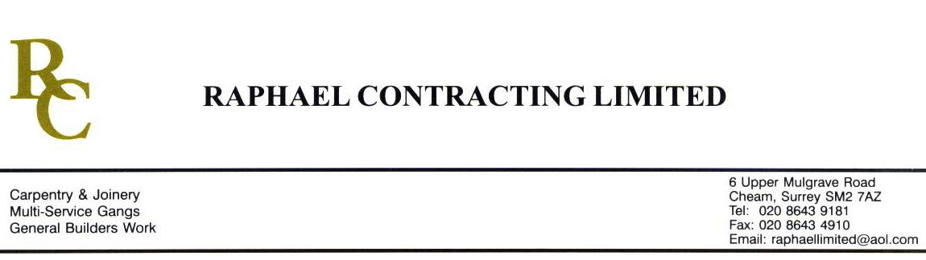

JMS

ADDENDUM ORDER

Ref: GLOUCESTER/ JMS 21 Date: 18/1/09

cc: Head Office

Dear Sirs,

Re: GLOUCESTER QUAYS

Please find attached the information as listed below.

You are instructed to vary your work as appropriate in order to incorporate these details.

Would you please advise us within 7 days of any cost implications.

Yours faithfully,
MARK ROBINSON

For and on behalf of
Raphael Contracting Limited

Subject/Location Instruction/Enclosures

RCL-SC-5000-P&L DOOR SCHEDULE Rev A
DY(32)7--99-504 Rev 01
DY(20)7--0-502 Rev 01
DY(20)7--1-503 Rev 04
DY(20)7--2-504 Rev 04
DY(20)7--3-505 Rev 04
DY(20)7--4-506 Rev 01

