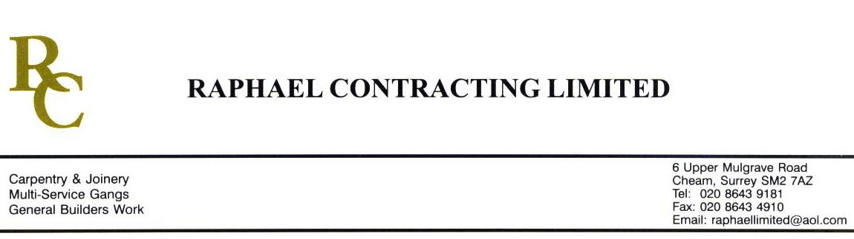

JMS JOINERY

ADDENDUM ORDER

Ref: GLOUCESTER/ JMS 24 Date: 20/1 /09

cc: Head Office

Dear Sirs,

Re: GLOUCESTER QUAYS

Please find attached the information as listed below.

You are instructed to vary your work as appropriate in order to incorporate these details.

Would you please advise us within 7 days of any cost implications.

Yours faithfully,
MARK ROBINSON

For and on behalf of
Raphael Contracting Limited

Subject/Location Instruction/Enclosures

PLEASE SUPPLY 188m2 OF REDWOOD T & G FLOOR BOARDS. Ex 175 x 25.

ALL TO BE FSC

Further to Mark’s addendum JMS 24 for supply of floor boards to Pillar & Lucy I confirm the rate agreed with Martin O’Brien of £1.90/m, description as your quote 5615h/AB/JJ

