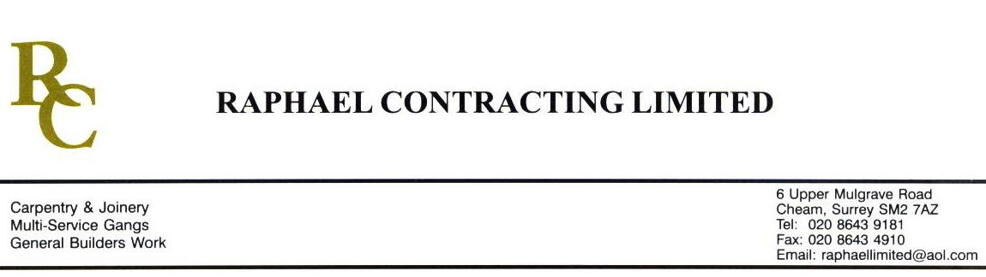

JMS JOINERY

ADDENDUM ORDER

Ref: GLOUCESTER/ JMS 27 Date: 26/ 1 /09

cc: Head Office

Dear Sirs,

Re: GLOUCESTER QUAYS

Please find attached the information as listed below.

You are instructed to vary your work as appropriate in order to incorporate these details.

Would you please advise us within 7 days of any cost implications.

Yours faithfully,
MARK ROBINSON

For and on behalf of
Raphael Contracting Limited

Subject/Location Instruction/Enclosures

PLEASE SUPPLY THE FOLLOWING FSC OAK ; - 15m x 70 x 40mm
5m x 70 x 50mm

FINISH TO BE AS OAK COLUMN CLADDING.

