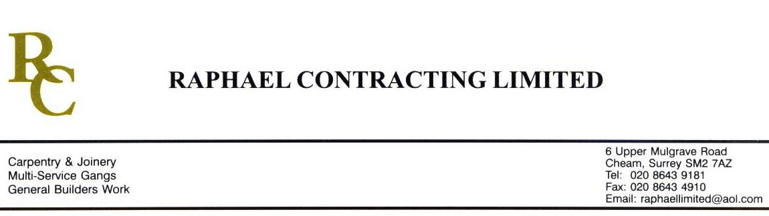

JMS JOINERY

ADDENDUM ORDER

Ref: GLOUCESTER/ JMS 32 Date: 30/ 1 /09

cc: Head Office

Dear Sirs,

Re: GLOUCESTER QUAYS

Please find attached the information as listed below.

You are instructed to vary your work as appropriate in order to incorporate these details.

Would you please advise us within 7 days of any cost implications.

Yours faithfully,
MARK ROBINSON

For and on behalf of
Raphael Contracting Limited

Subject/Location Instruction/Enclosures

PLEASE SUPPLY ONLY, KITCHENS TO MANAGEMENT SUITE ( 2 No )
PILLAR AND LUCY ( 4 No )
DRAWWINGS ATTACHED ; - DY(74)7 - - 99-503 Rev 01
506 Rev 00
509 Rev 01
510 Rev 01

