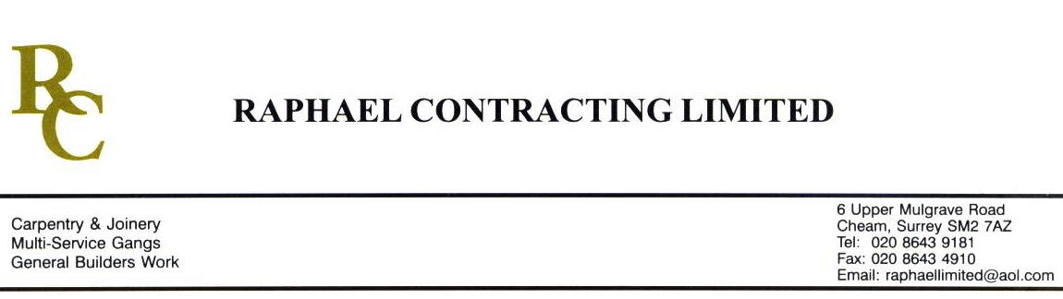

JMS JOINERY

ADDENDUM ORDER

Ref: GLOUCESTER/ JMS 57 Date: 5/ 3 /09

cc: Head Office

Dear Sirs,

Re: GLOUCESTER QUAYS

Please find attached the information as listed below.

You are instructed to vary your work as appropriate in order to incorporate these details.

Would you please advise us within 7 days of any cost implications.

Yours faithfully,
MARK ROBINSON

For and on behalf of
Raphael Contracting Limited

Subject/Location Instruction/Enclosures

MANAGEMENT SUITE ;-
1, PLYWOOD PATRESSES 595 x 595 x 6mm
81 No WITH 210mmØ HOLE, 1 No WITH 160mmØ HOLE, 22 No WITH 255 x 255mm, 4 No WITH 305 x 305mm.
2, FOC DOOR SCHEDULE Rev A.

PILLAR & LUCY ;-
OAK POSTS c/w LACQUER. 3@ 2500 x 100 x 70mm, 2@ 2500 x 70 x 70mm,
1@ 2500 x 30 x 70mm, 6@ 2500 x 30 x 125mm.

