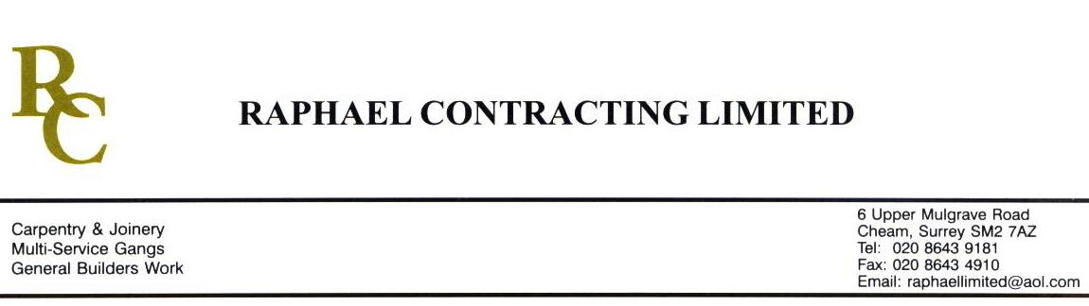

JMS JOINERY

ADDENDUM ORDER

Ref: BRISTOL/ JMS 32 Date: 27 / 1 /09

cc: Head Office

Dear Sirs,

Re: CABOT CIRCUS

Please find attached the information as listed below.

You are instructed to vary your work as appropriate in order to incorporate these details.

Would you please advise us within 7 days of any cost implications.

Yours faithfully,
MARK ROBINSON

For and on behalf of
Raphael Contracting Limited

Subject/Location Instruction/Enclosures

PLEASE SUPPLY THE FOLLOWING ; - 30m x 128 x 12mm AMERICAN WHITE OAK ( UNTREATED ).
2. S/S ANGLE TO GO AROUND 4 EDGES OF EACH DOOR ( SEE ATTACHED DRAWING ) INTERNAL SIZE 12 x 12mm.
3. OAK GLAZING BEAD TO EACH SIDE OF 1 DOOR, 44mm THICK DOOR WITH BEAD TO COME FLUSH WITH OAK CLADDING.
4. FIRE GLASS TO SUIT APPATEUR.

