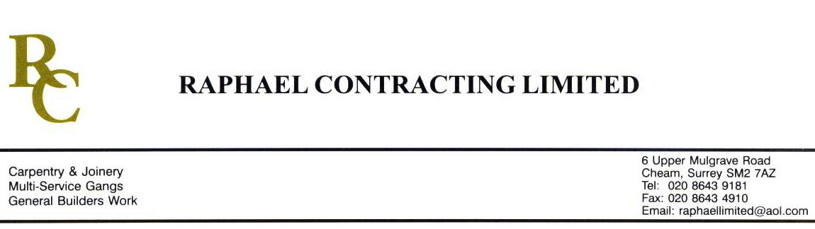

SIF

ADDENDUM ORDER

Ref: GLOUCESTER/ SIF 107 Date: 11/ 5 /09

cc: Head Office

Dear Sirs,

Re: GLOUCESTER QUAYS

Please find attached the information as listed below.

You are instructed to vary your work as appropriate in order to incorporate these details.

Would you please advise us within 7 days of any cost implications.

Yours faithfully,
MARK ROBINSON

For and on behalf of
Raphael Contracting Limited

Subject/Location Instruction/Enclosures.

PLEASE CONSTRUCT 700 x 700 x 700mm PLASTERBOARD BOX’S AROUND THE 3 No SPOTLIGHTS ON THE ATRIUM FLOOR, PLASTERBOAD ON BOTH SIDES, FIXED TO CHIPBOARD FLOOR. TO BE TAPED & JOINTED AND WITHOUT LID.

