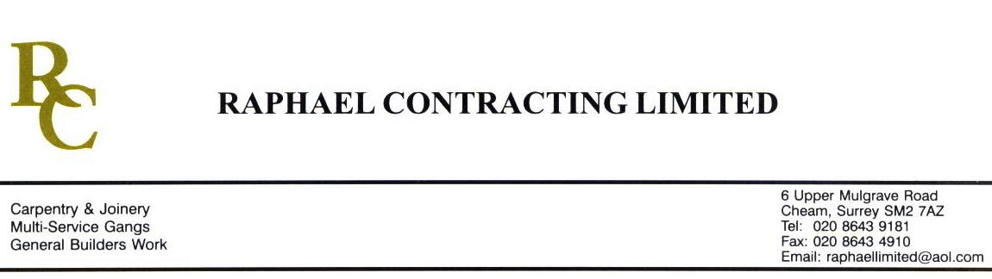

SIF

ADDENDUM ORDER

Ref: GLOUCESTER/ SIF 123 Date: 8 / 6 /09

cc: Head Office

Dear Sirs,

Re: GLOUCESTER QUAYS

Please find attached the information as listed below.

You are instructed to vary your work as appropriate in order to incorporate these details.

Would you please advise us within 7 days of any cost implications.

Yours faithfully,
MARK ROBINSON

For and on behalf of
Raphael Contracting Limited

Subject/Location Instruction/Enclosures.

PILLAR & LUCY

- PLEASE SUPPLY & FIT 3 No 600 x 600mm ACCESS PANELS IN 4th FLOOR CORRIDOR CEILING ADJACENT TO BOILER ROOM.
- FORM BULKHEAD TO COVER IN 4th FLOOR HEATING PIPES ON THE SOUTH SIDE.
BLLI-18111

