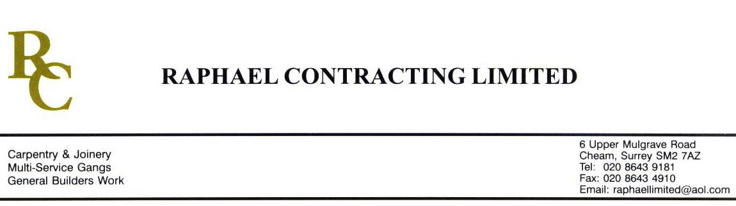

SIF

ADDENDUM ORDER

Ref: GLOUCESTER/ SIF 26 Date: 20/1 /09

cc: Head Office

Dear Sirs,

Re: GLOUCESTER QUAYS

Please find attached the information as listed below.

You are instructed to vary your work as appropriate in order to incorporate these details.

Would you please advise us within 7 days of any cost implications.

Yours faithfully,
MARK ROBINSON

For and on behalf of
Raphael Contracting Limited

Subject/Location Instruction/Enclosures

MANAGEMENT SUITE DRAWINGS ; - DY(42)1—1-515 Rev 07
516 Rev OO
517 Rev 01
518 Rev 01

