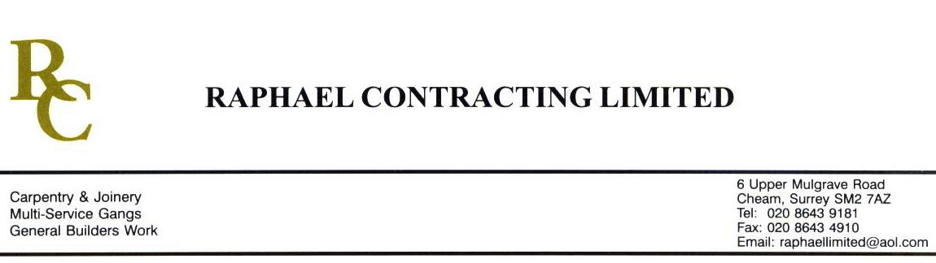

SIF

ADDENDUM ORDER

Ref: GLOUCESTER/ SIF 37 Date: 31/ 1 /09

cc: Head Office

Dear Sirs,

Re: GLOUCESTER QUAYS

Please find attached the information as listed below.

You are instructed to vary your work as appropriate in order to incorporate these details.

Would you please advise us within 7 days of any cost implications.

Yours faithfully,
MARK ROBINSON

For and on behalf of
Raphael Contracting Limited

Subject/Location Instruction/Enclosures

LATEST REVISION DRAWINGS ;- FOC DY(20)1H-1-001 REV 07
DY(99)1- -99-311 Rev 00
“ “ 312 Rev 00

PILLAR & LUCY ;- DY(20)7- -1-503 REV 04 DY(27)7- - 4-501 REV 00
2-504 REV 04 4-506 REV 00
3-505 REV 04 99-505 REV 01
DY(22)7- - 1-503 REV 03 99-038 REV 00
2-504 REV 03 99-039 REV 00
3-505 REV 03 99-040 REV 00
3-511 REV 00

