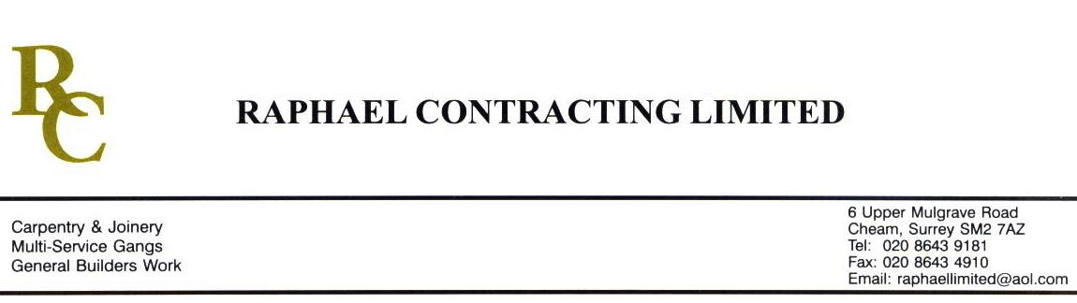

SIF

ADDENDUM ORDER

Ref: GLOUCESTER/ SIF 42 Date: 5/ 2 /09

cc: Head Office

Dear Sirs,

Re: GLOUCESTER QUAYS

Please find attached the information as listed below.

You are instructed to vary your work as appropriate in order to incorporate these details.

Would you please advise us within 7 days of any cost implications.

Yours faithfully,
MARK ROBINSON

For and on behalf of
Raphael Contracting Limited

Subject/Location Instruction/Enclosures

- PLEASE KEEP ALL PLASTERBOARDS IN THE MANAGEMENT SUITE AT LEAST 15mm OFF THE FLOOR.
- REMOVE PLASTREBOARDS AND THEN MAKE GOOD APPROX 4 AREA’S IN THE MANAGEMENT SUITE TO ALLOW T. CLARKE TO INSTALL EXTERNAL LIGHTS.
- HIRE IN 2 No GAS HEATERS (1 WK HIRE ) TO DRY OUT THE MANAGEMENT SUITE WALLS.

