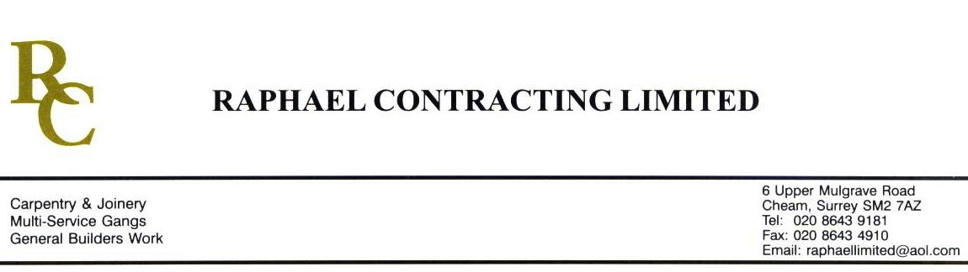

SIF

ADDENDUM ORDER

Ref: GLOUCESTER/ SIF 63 Date: 14/ 3 /09

cc: Head Office

Dear Sirs,

Re: GLOUCESTER QUAYS

Please find attached the information as listed below.

You are instructed to vary your work as appropriate in order to incorporate these details.

Would you please advise us within 7 days of any cost implications.

Yours faithfully,
MARK ROBINSON

For and on behalf of
Raphael Contracting Limited

Subject/Location Instruction/Enclosures

- CARRY OUT REPAIRS TO WALLS IN THE MANAGEMENT SUITE. NOTE ;- CAN YOU TAKE PHOTOGRAPHIC EVIDENCE BEFORE AND AFTER ANY REPAIR.
- PLEASE SUPPLY INTUMESCENT PADS FOR 100 SINGLE AND 60 DOUBLE SOCKETS IN THE MANAGEMENT SUITE.
- GIP LINE THE BACK OF STAIR 2 WALLS ON ALL LEVELS IN PILLAR & LUCY WERE THEY ARE IN A NEWLY BUILT ROOM.
- REMOVE PLASTERBOARD ON 1 ELEVATION ON THE G/FLOOR PLANT ROOM TO ALLOW CLARKE’S TO INSTALL UNIT. THEN REPLACE BOARDS.

