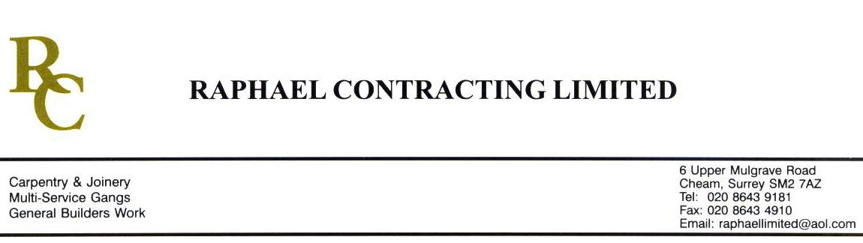

SIF

ADDENDUM ORDER

Ref: GLOUCESTER/ SIF 65 Date: 21/ 3 /09

cc: Head Office

Dear Sirs,

Re: GLOUCESTER QUAYS

Please find attached the information as listed below.

You are instructed to vary your work as appropriate in order to incorporate these details.

Would you please advise us within 7 days of any cost implications.

Yours faithfully,
MARK ROBINSON

For and on behalf of
Raphael Contracting Limited

Subject/Location Instruction/Enclosures.

MANAGEMENT SUITE
- SUPPLY & FIT ROCKFON CEILING TILES IN MALE & FEMALE SHOWER ROOMS.
- SUPPLY & FIT 50mm ROCKWOOL 45kg/m3 BENEATH CILL BOARDS. INSTALL HORIZONTALLY WITH VISQUEEN AGAINST THE BRICKWORK. (ZONE 2)
PILLAR & LUCY
- FIRE PROTECT G/FLOOR BEAM WITH 2 LAYERS 15mm FIRELINE & DECORATE WITH 2 COATS EMULSION.
- MAKE GOOD AROUND NEW ROOF LIGHT ON LEVEL 4.
BLOCK P
1. INSTALL PLASTERBOARD WALL BEHIND 3 WINDOWS APPROX 1100mm HIGH.

