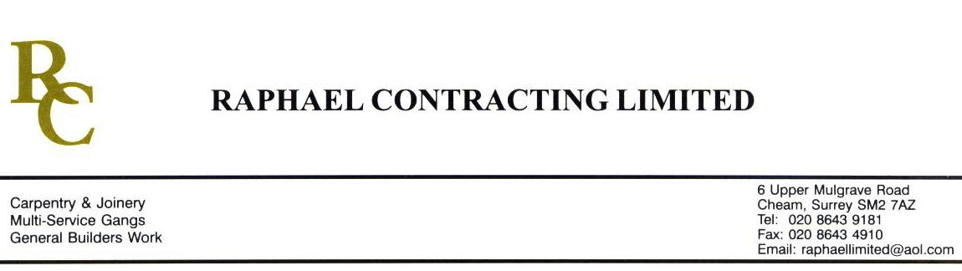

SIF

ADDENDUM ORDER

Ref: GLOUCESTER/ SIF 72 Date: 30/ 3 /09

cc: Head Office

Dear Sirs,

Re: GLOUCESTER QUAYS

Please find attached the information as listed below.

You are instructed to vary your work as appropriate in order to incorporate these details.

Would you please advise us within 7 days of any cost implications.

Yours faithfully,
MARK ROBINSON

For and on behalf of
Raphael Contracting Limited

Subject/Location Instruction/Enclosures.

- PLEASE CARRY OUT ALL CEILING AND WALL REPAIRS IN PILLAR AND LUCY CAUSED BY T.CLARKES.
- PLEASE CARRY ON WITH DRY LINING WORKS IN PHASE 3 OF THE MANAGEMENT SUITE.

