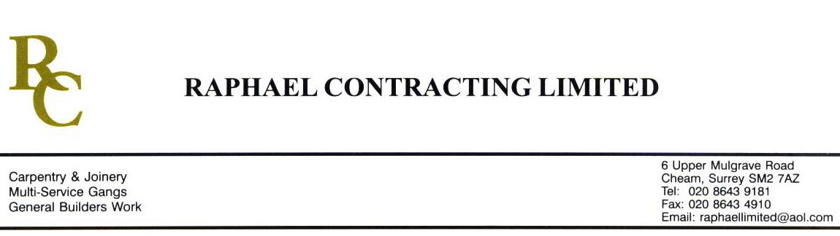

SIF

ADDENDUM ORDER

Ref: GLOUCESTER/ SIF 82 Date: 4/ 4 /09

cc: Head Office

Dear Sirs,

Re: GLOUCESTER QUAYS

Please find attached the information as listed below.

You are instructed to vary your work as appropriate in order to incorporate these details.

Would you please advise us within 7 days of any cost implications.

Yours faithfully,
MARK ROBINSON

For and on behalf of
Raphael Contracting Limited

Subject/Location Instruction/Enclosures.

PLEASE CARRY OUT THE FOLLOWING ; -
MANAGEMENT SUITE
- TAPE & JOINT CUPBOARD IN THE MANAGEMENT SUITE MESS ROOM.
- PROVIDE GYPLINER TO CORE 1:7, SIDE WALL ADJACENT TO STAIR STRING AND BOX OUT EXPOSED BEAM.
- PROVIDE DRY LINING TO RAKE OF STAIR STRING IN CORE 1:11 TO ALLOW HANDRAIL TO BE FIXED.
PILLAR & LUCY
- BUILD FIRE ALARM ENCLOSURE ON GROUND FLOOR OF PILLAR & LUCY AS…. DY(99)7- -99-048 Rev 00

