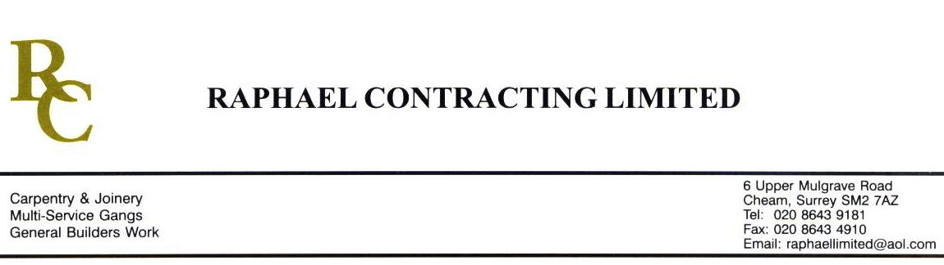

SIF

ADDENDUM ORDER

Ref: GLOUCESTER/ SIF 84 Date: 7/ 4 /09

cc: Head Office

Dear Sirs,

Re: GLOUCESTER QUAYS

Please find attached the information as listed below.

You are instructed to vary your work as appropriate in order to incorporate these details.

Would you please advise us within 7 days of any cost implications.

Yours faithfully,
MARK ROBINSON

For and on behalf of
Raphael Contracting Limited

Subject/Location Instruction/Enclosures.

PLEASE LOWER THE ALREADY INSTALLED CORRIDOR CEILING BY 50mm BETWEEN THE CASH OFFICE AND THE BOILER ROOM IN THE MANAGEMENT SUITE.

