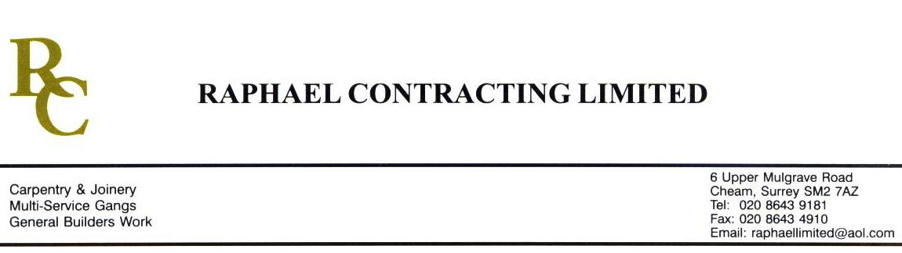

SIF

ADDENDUM ORDER

Ref: GLOUCESTER/SIF 101 Date: 6/ 5 /09

cc: Head Office

Dear Sirs,

Re: GLOUCESTER QUAYS

Please find attached the information as listed below.

You are instructed to vary your work as appropriate in order to incorporate these details.

Would you please advise us within 7 days of any cost implications.

Yours faithfully,
MARK ROBINSON

For and on behalf of
Raphael Contracting Limited

Subject/Location Instruction/Enclosures.

PILLAR & LUCY

1, PLEASE SUPPLY & INSTALL 1 x 450 x 450mm, 60Min FR ACCESS PANEL IN ROOM 4-008 RISER.
2, REMOVE 300mm WIDE SECTION OF FIRE CEILING ON THE GROUND FLOOR TO ALLOW SVP TO BE INSTALLED THEN RE-INSTATE.
3, CARRY OUT ALTERATIONS TO GROUND FLOOR FIRE PANEL BOX TO SUIT PROTEC BOX.

