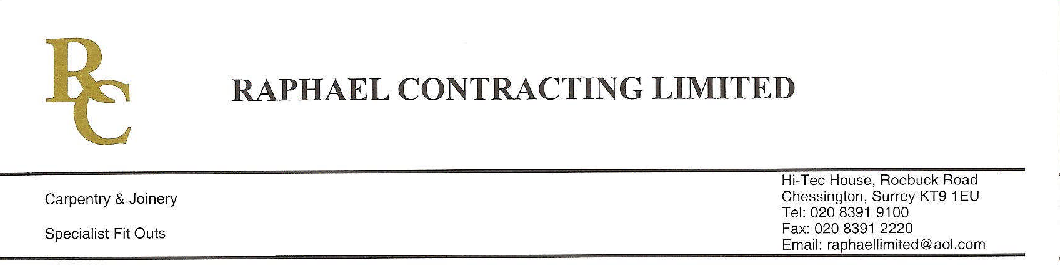
ADDENDUM ORDER

Ref: RC/allgoods 001

DATE:03/02/09

cc Head Office
Dear Sirs,

ADDENDUM ORDER

Ref: RC/allgoods002

Date: 26/03/09

cc: H.O.

Dear Sirs,

Re: WEBB HOUSE

Please find attached the information as listed below.

You are instructed to vary your work as appropriate in order to incorporate these details.

Would you please advise us within 7 days of any cost implications.

Yours faithfully,

For and on behalf of
Raphael Contracting Limited

Subject/Location:-Lock suiting details

Instruction/Enclosures:-Please find attached lock suiting details

