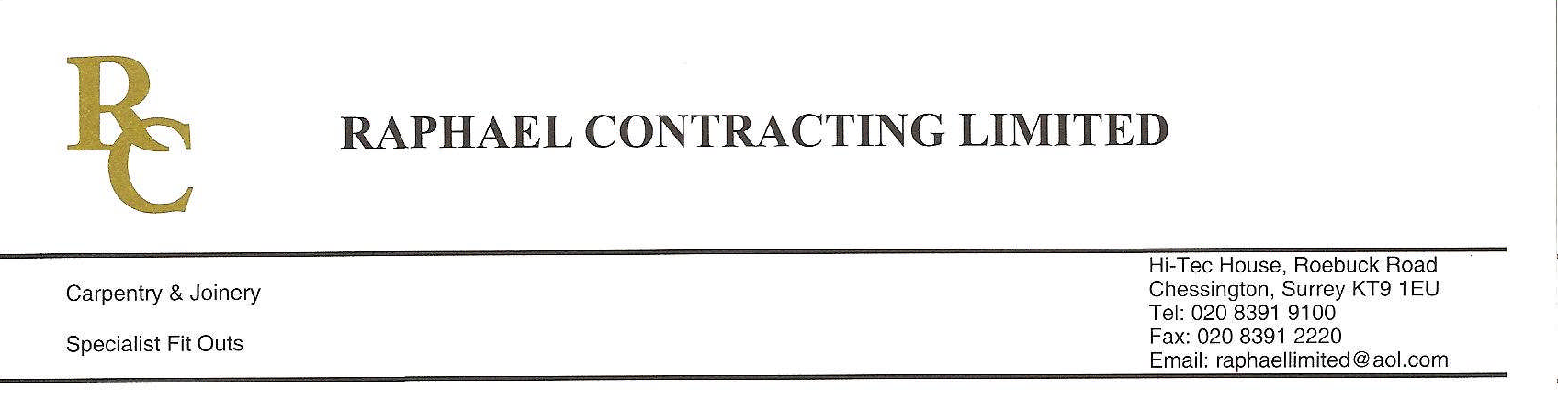
ADDENDUM ORDER

Ref: RC/allgoods 001

DATE:03/02/09

cc Head Office
Dear Sirs,

ADDENDUM ORDER

Ref: RC/allgoods003

Date: 12/05/09

cc: H.O.

Dear Sirs,

Re: WEBB HOUSE

Please find attached the information as listed below.

You are instructed to vary your work as appropriate in order to incorporate these details.

Would you please advise us within 7 days of any cost implications.

Yours faithfully,

For and on behalf of
Raphael Contracting Limited

Subject/Location:-Lock suiting Floor plan drawing issue
All floors

Instruction/Enclosures:-Please find attached both office and Residential floor plans
To allow suiting of cylinders
Drawings as listed below
OFFICE DRAWINGS
(-) 02 G ,03 T ,04 K ,05 J ,06 K ,07 J ,09 L ,10 J ,11 J ,13 M ,14 F
RESIDENTIAL DRAWINGD
(-) 20 L ,21 N ,22 M ,23 P,24 N,25 M,26 L

