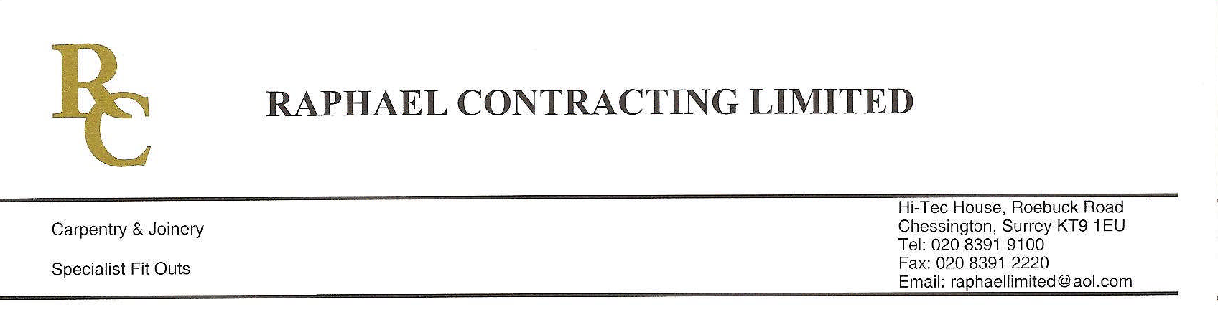
ADDENDUM ORDER

Ref: RC/allgoods 001

DATE:03/02/09

cc Head Office
Dear Sirs,

ADDENDUM ORDER

Ref: RC/allgoods004

Date: 17/08/09

cc: H.O.

Dear Sirs,

Re: WEBB HOUSE

Please find attached the information as listed below.

You are instructed to vary your work as appropriate in order to incorporate these details.

Would you please advise us within 7 days of any cost implications.

Yours faithfully,

For and on behalf of
Raphael Contracting Limited

Subject/Location:-EXTRA IRONMONGERY DG 024 & 025

Instruction/Enclosures:-Please supply extra ironmongery for door sets
DG 24 & 25 all as your quote ref DHAY-7UFAJVLO

Please advise best delivery dates?

