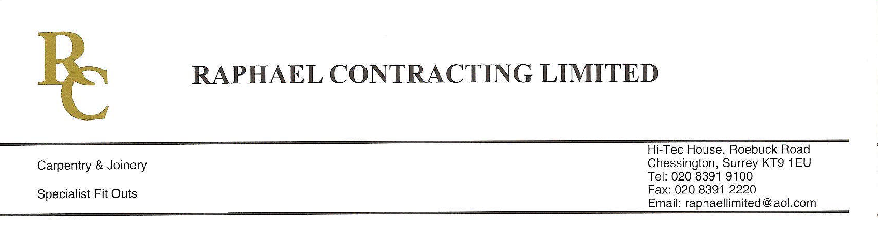
ADDENDUM ORDER

Ref: RC/allgoods 001

DATE: 03/02/09

cc Head Office
Dear Sirs,

ADDENDUM ORDER

Ref: RC/allgoods007

Date: 02/09/09

cc: H.O.

Dear Sirs,

Re: WEBB HOUSE

Please find attached the information as listed below.

You are instructed to vary your work as appropriate in order to incorporate these details.

Would you please advise us within 7 days of any cost implications?

Yours faithfully,

For and on behalf of
Raphael Contracting Limited

Subject/Location:-All floors stair 2 and 3 half lever handles

Instruction/Enclosures:-
PLEASE SUPPLY 12 number ST41027TFL
FSB design lever handle turnably fixed to rose, supplied without spindle,
Left hand
If possible exchange 12 number spare right hand levers?

