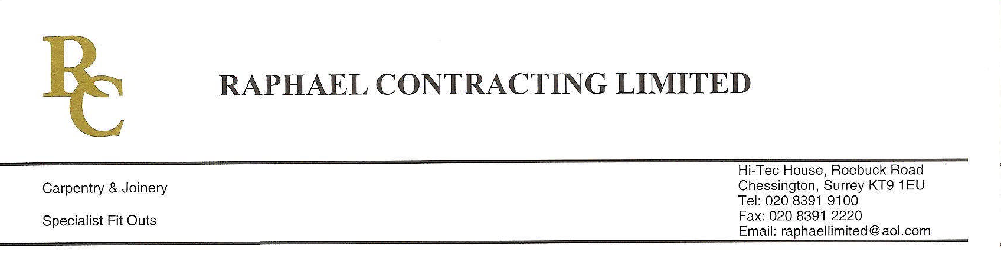
ADDENDUM ORDER

Ref: RC/allgoods 001

DATE: 03/02/09

cc Head Office
Dear Sirs,

ADDENDUM ORDER

Ref: RC/allgoods008

Date: 09/09/09

cc: H.O.

Dear Sirs,

Re: WEBB HOUSE

Please find attached the information as listed below.

You are instructed to vary your work as appropriate in order to incorporate these details.

Would you please advise us within 7 days of any cost implications?

Yours faithfully,

For and on behalf of
Raphael Contracting Limited

Subject/Location:-EXTRA IRONMONGERY

Instruction/Enclosures:-
PLEASE SUPPLY THE FOLLOWING EXTRA IRONMOGERY

3 number intumescent packs XX9133 FP
3 number concealed door closers SS 9133 S
1 number SS786F60 lock case
4 number SS7679F60 lock case

