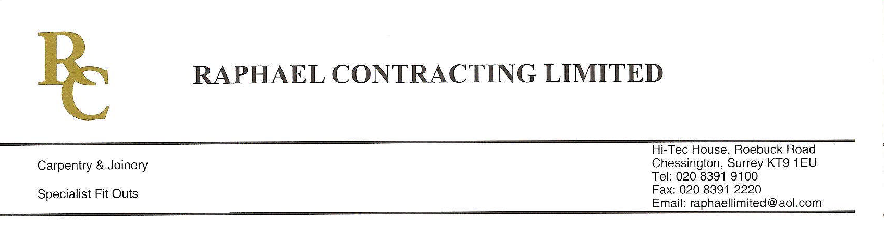
ADDENDUM ORDER

Ref: RC/allgoods 001

DATE: 03/02/09

cc Head Office
Dear Sirs,

ADDENDUM ORDER

Ref: RC/allgoods009

Date: 29/10/09

cc: H.O.

Dear Sirs,

Re: WEBB HOUSE

Please find attached the information as listed below.

You are instructed to vary your work as appropriate in order to incorporate these details.

Would you please advise us within 7 days of any cost implications?

Yours faithfully,

For and on behalf of
Raphael Contracting Limited

Subject/Location:-EXTRA IRONMONGERY

Instruction/Enclosures:-
PLEASE SUPPLY THE FOLLOWING EXTRA IRONMOGERY

1 Number replacement cylinder with turn for door RDG 11
Door thickness 60mm

