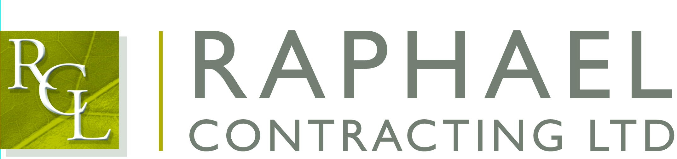

Private and Confidential

7th June 2018

Dear Danny,

I am pleased that you are able to join us for the Football’s Coming Home Lunch on the 8th June 2018 at The Brewery, London, 52 Chiswell Street, London EC1.

The function commences with a drinks reception at 12:00 followed by lunch at 12.30; the event finishes at approximately 4:00pm.

If anyone is feeling thirsty we shall be meeting in the All Bar One, 127 Finsbury Pavement, London EC2 beforehand.

If you have any special dietary requirements, would you please let Elly Scane at our Chessington office know as soon as possible.

The guest speakers are Peter Reid, Peter Shilton, John Barnes, Paul Gascoigne, Paul Merson, Michael Owen & John Motson.

There will be a post-event bar in the Smeaton Vaults until 7.30pm to enable guests to continue networking after the entertainment finishes.

Please note dress code is Lounge Suit.

I will look forward to seeing you on the 8th

Yours sincerely,

Richard Hayhoe

Cc: Martin O’Brien

