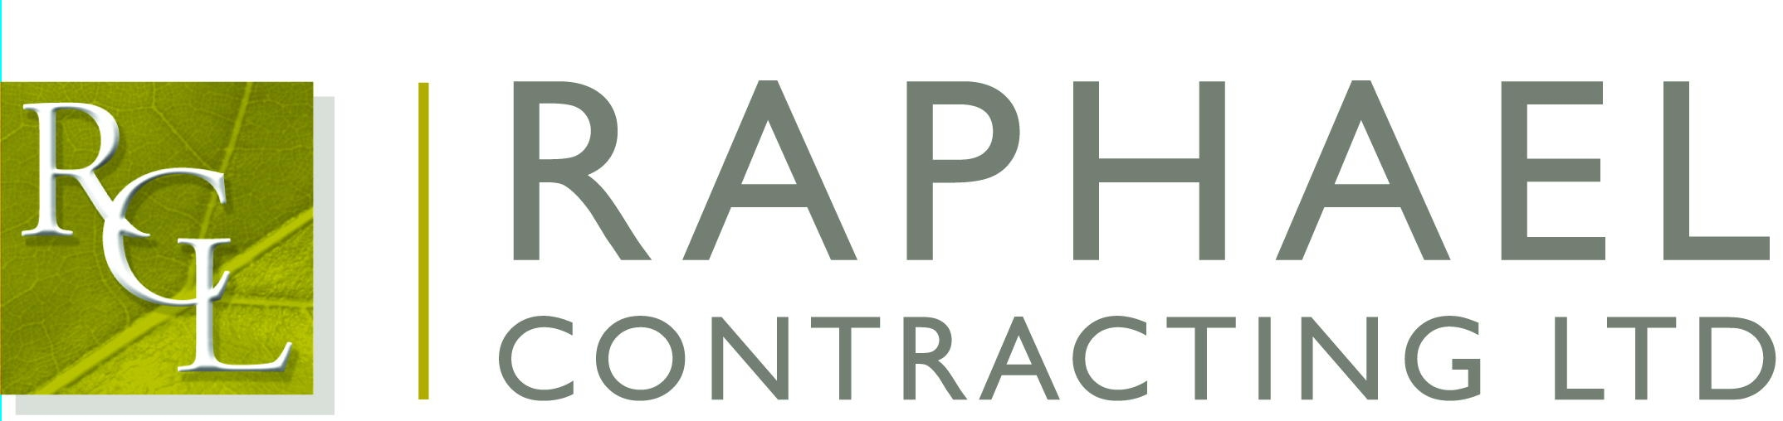

Private and Confidential

6th March 2018

Dear George,

I am pleased that you are able to join us for the Six Nations Podcast Special Lunch on Friday 9th of March 2018, to be held at The Brewery, 52 Chiswell Street, London EC1.

The function commences with a drinks reception at 12:00 followed by lunch at 12.30; the event finishes at approximately 4:00pm.

If anyone is feeling thirsty we shall be meeting in the All Bar One, 127 Finsbury Pavement, London EC2 beforehand.

If you have any special dietary requirements, would you please let Elly Scane at our Chessington office know as soon as possible.

The guest speakers are Jim Hamilton, Andy Goode, Tom Shanklin, Andy Powell, Martin Johnson CBE and Doddie Weir. The lunch will be hosted by David Flatman.

Post-event, the guys will be hosting a ‘Live Podcast’ from the Brewery which is open to all guests to stick around and enjoy from 4:10pm.

Please note dress code is Lounge Suit.

I will look forward to seeing you on the 9th

Yours sincerely,

Richard Hayhoe

Cc: Martin O’Brien

