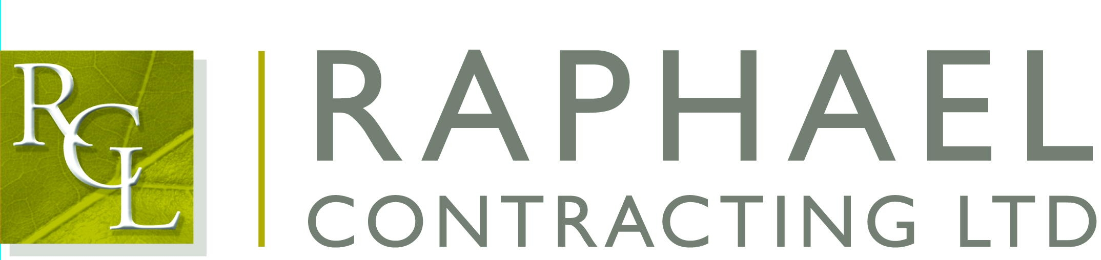

Private and Confidential

2nd of March 2017
Dear Neil Tilbury,

I am pleased that you are able to join us for the Racy Rugby Lunch on Friday 10th of March 2017, to be held at The Brewery, 52 Chiswell Street, London EC1.

The function commences with a drinks reception at 12:00 followed by lunch at 12.45; the event finishes at approximately 4:00pm.

If anyone is feeling thirsty we shall be meeting in the All Bar One, 127 Finsbury Pavement, London EC2 beforehand.

If you have any special dietary requirements, would you please let Elly Scane at our Chessington office know as soon as possible.

The guest speakers are Sir Ian McGeehan, Mike Tindall, Graham Rowntree & AP McCoy. The lunch will be hosted by David Flatman.
Please note dress code is Lounge Suit.

Also for those that may be interested, there will be a Cheltenham preview after the event where there will be free beer for all attendees!

I will look forward to seeing you on the 10th.

Yours sincerely,

Richard (Hayhoe)

Cc: Martin O’Brien

