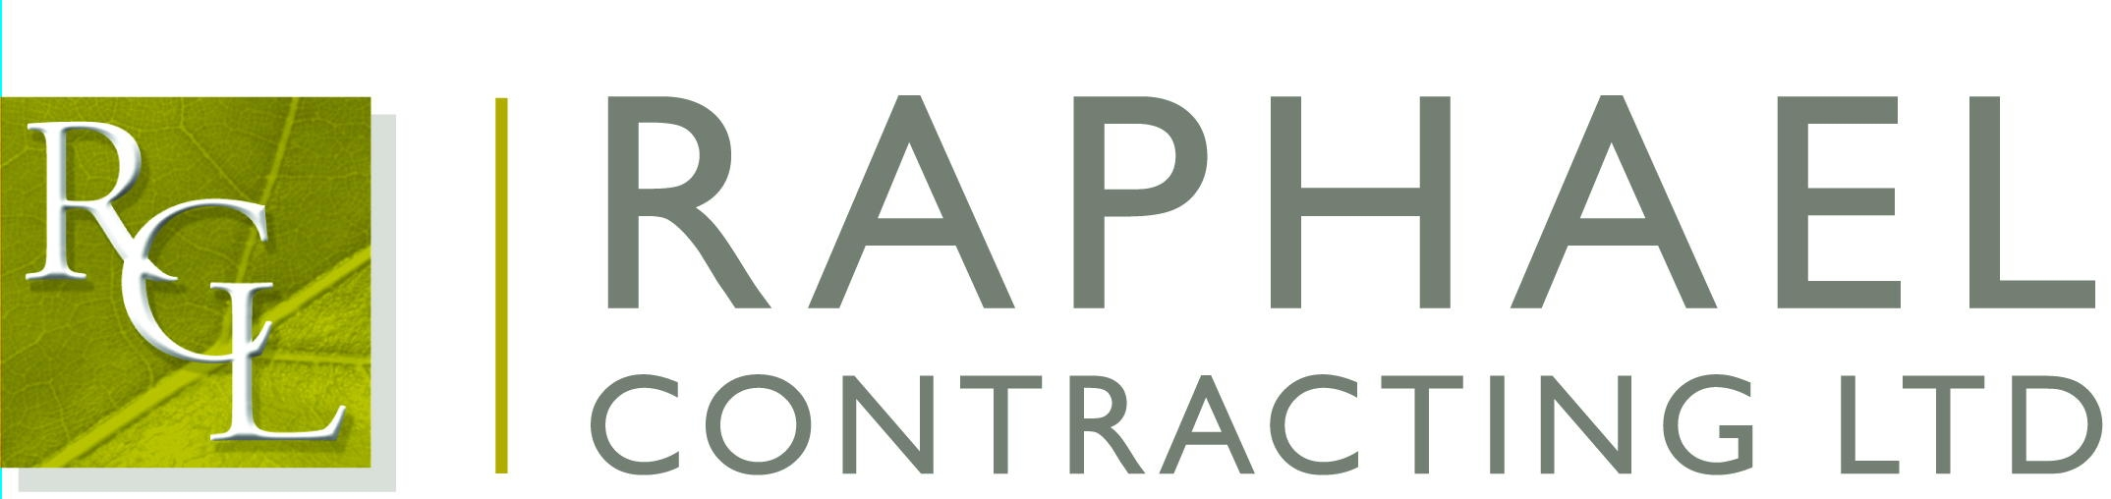

Private and Confidential

26th of September 2016
Dear ……….

I am pleased that you are able to join us for the Rugby Speaker of the Year 2016 on Friday 14th of October 2016, to be held at The Brewery, 52 Chiswell Street, London EC1.

The function commences with a drinks reception at 12:00 followed by lunch at 12.45; the event finishes at approximately 3:30pm.

If anyone is feeling thirsty we shall be meeting in the All Bar One, 127 Finsbury Pavement, London EC2 beforehand.

If you have any special dietary requirements, would you please let Elly Scane at our Chessington office know as soon as possible.

The guest speakers are Shane Williams, Nigel Owens, John Bentley & Eddie Jones. The lunch will be hosted by David Flatman.
Please note dress code is Lounge Suit.

I will look forward to seeing you on the 14th.

Yours sincerely,

Richard (Hayhoe)

Cc: Martin O’Brien, James Hayhoe and Dave Sanders

