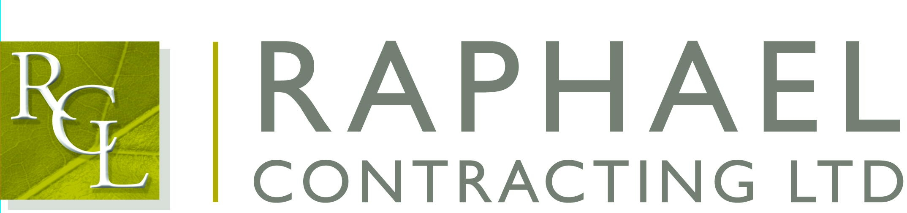

Private and Confidential

31st of March 2017
Dear,

I am pleased that you are able to join us for the Maggies Golf Day on Friday 26th of May 2017, to be held at The Shire Course, St Albans Road, Barnet EN6 4RE.

The format for the day will be: -

7.30-8am Arrival at the course with Coffee/Rolls

8.30am Briefing about the rules for the day

8.40am Depart clubhouse for allocated hole/start

9am Shotgun start

2pm Golf complete and return to clubhouse for buffet lunch, prizes, awards, auction and raffle

3pm Depart for Bank Holiday Weekend

All handicaps will be required 2 weeks prior to the event, please confirm your handicaps as soon as possible.

I will look forward to seeing you on the 26th.

Yours sincerely,

Richard (Hayhoe)

Cc: Martin O’Brien

