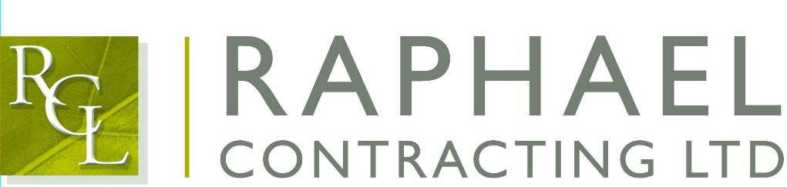

**Private and Confidential**

3rd of April 2017

Dear Robin,

I am pleased that you are able to join us for the Maggies Golf Day on Friday 26th of May 2017, to be held at The Shire Course, St Albans Road, Barnet EN6 4RE.

The format for the day will be: -

7.30-8am             Arrival at the course with Coffee/Rolls

8.30am                 Briefing about the rules for the day

8.40am                 Depart clubhouse for allocated hole/start

9am                      Shotgun start

2pm                      Golf complete and return to clubhouse for buffet lunch, prizes, awards, auction and raffle

3pm                      Depart for Bank Holiday Weekend

All handicaps are required this week if possible, please confirm.

The day will be attended by our Dave Sanders and Paul Haugh. Their mobile numbers are below to make contact them on the morning.

Dave Sanders – 07967331912

Paul Haugh - 07970045912

We wish you a really enjoyable day.

Yours sincerely,

Martin O’Brien

Cc: Richard Hayhoe