JMS Specialist Joinery Ltd
Unit B Bourne End
Kineton Road
Southam
CV47 0NA 30th October 2023

For the attention of Mr J Gould

Dear Sirs,

Re: The National Gallery, London

We enclose herewith our Order No 33417 for the supply of joinery at the above.

All timber based products for this project are to be accredited as either FSC 100% or FSC 70% mix and are to have full chain of custody.

We trust this is self-explanatory but, should you have any queries, please contact the undersigned.

Yours faithfully,
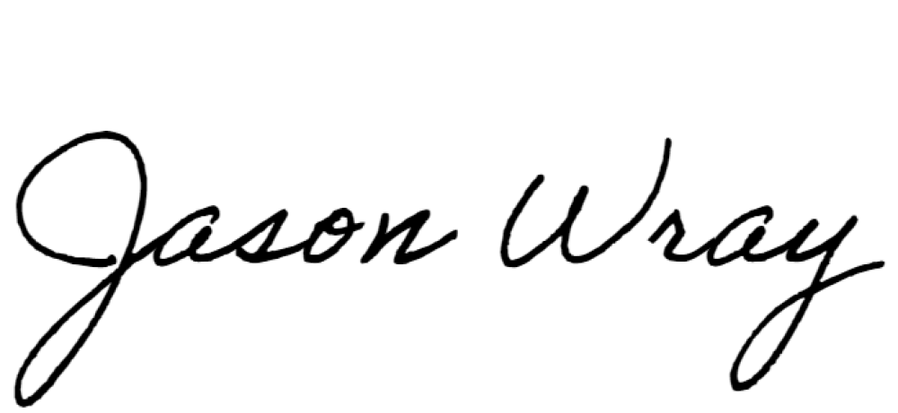

Jason Wray

cc R C Hayhoe
M O’Brien
S Thorpe
P Haugh
D Singh
P Bennett
J Hayhoe

