## Raphael Contracting Ltd

National Gallery

## Quote Date : Quote no :

**Valid Until :**

19 Dec, 2023 RS14094

18 Jan, 2024

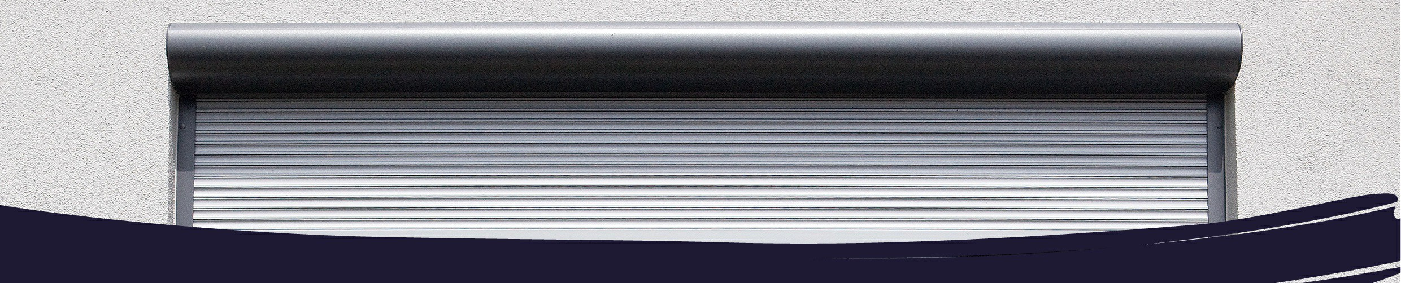

Dear Mr. Jason Wray,

## Re: Your Shutters enquiry

Thank you for your recent enquiry. I have the pleasure of enclosing your quotation based on the information you've provided

In addition to the details laid out in your quotation, I would like to highlight some of the reasons why customers choose to use Roché for their Shutters.

## Helping you find the best solution

Established in 2000, Roché have over 20 years experience and only use highly trained, professional and trusted surveyors with excellent product knowledge. This helps us find the best model to suit to your home or business.

We are a UK leader in providing bespoke awning and security solutions

## Full product and fitting guarantee

Each product is designed and installed to meet your exact needs. This is why we offer a full guarantee on the product and any workmanship involved.

## With you from design to installation

Roché staff are available to advise at every stage - providing technical advice, and offering up to date information regarding your order. Our team will then return to take care of the installation at a time to suit you and making sure everything fits perfectly.

Yours faithfully,

Jodie Ellis

# BILLING ADDRESS

Raphael Contracting Ltd National Gallery

# INSTALLATION ADDRESS

National Gallery

.

# CONTACT DETAILS

Mr. Jason Wray 020 8391 9100

[Jason@raphaelltd.co.uk](mailto:Jason@raphaelltd.co.uk)



|  |  |  |  |  |  |
| --- | --- | --- | --- | --- | --- |
| **#** | **PRODUCT** |  | **QTY** | **LIST PRICE** | **TOTAL** |
| 1. |  | [**V77 - Aluminium Security Shutter**](https://www.rochesecurity.com/product/v77/) | 1 |  |  |
|  |  | Double skinned 77mm extruded aluminium polyester powder coated slat. Electric operation with an external key switch. Manual override facility to be utilised in the event of a power failure. To include polycarbonate inserts. |  |  |  |
|  |  | 5200mm w x 3500mm h |  |  |  |
|  |  | [Product Datasheet](https://www.rochesecurity.com/downloads/datasheets/FS60-Fire-Shutter-Datasheet.pdf) |  |  |  |
|  |  | [BIM](https://www.nationalbimlibrary.com/en-gb/roche-systems-ltd/v77-aluminium-security-shutter/?lo=en) |  |  |  |
| 2. |  | [**FS60 - 1 Hour Fire Rated Fire Shutter**](https://www.rochesecurity.com/product/fs60/) | 2 |  |  |
|  |  | 4352mm w x 2500mm h Sizes assumed. |  |  |  |
|  |  | [Commercial Brochure](https://crm.zoho.eu/crm/org20071357768/%24%7BProducts.Brochure%20URL%7D) [Product Datasheet](https://www.rochesecurity.com/downloads/datasheets/FS60-Fire-Shutter-Datasheet.pdf) [CAD](https://www.rochesecurity.com/downloads/dwg/FS60-Fire-Shutter-DWG-CAD.dwg)  [BIM](https://www.nationalbimlibrary.com/en-gb/roche-systems-ltd/fs60-fire-shutter/?lo=en) |  |  |  |
| 3. |  | **Commission** | 1 |  |  |
|  |  | Commission of existing shutter. Providing shutter is in good working order. |  |  |  |

# PRICES

All prices for an accepted order are final and not subject to change unless otherwise agreed and subject to a site survey. 50% deposit required to secure the order.

# PAYMENT

Payment Methods: Debit/Credit Card. Direct Transfer

Please make all BAC/CHAPS payments payable to: Account Name: Roche Systems Ltd, Sort Code: 30-97-62, Account Number: 63189260, Payment Reference: RS14094

# WARRANTY

Inclusive of installation and comes complete with a product and workmanship guarantee. We aim to rectify any unexpected issues / accidental damage as soon as possible.

# DELIVERY

Manufacture delivery dates are approximate and subject to change.

# DRAWINGS

We will provide site specific drawings for approval where requested.

# ACCESS

Roché will provide access and lifting equipment required for our installation only, unless instructed otherwise by client.

Distribution of parts and materials above or below ground floor level will be subject to site survey. An aborted installation charge will apply if we are unable to gain access on the agreed date of installation.

# POWER SUPPLY

Single phase motors require a 13 amp power supply / Three phase motors require a 16 amp 5 pin female isolator socket. Please note that if a suitable power supply is not made available on the agreed date of installation an additional charge will be applied for each commissioning revisit.

# OTHER INFORMATION

This quotation is subject to our [terms and conditions](https://www.rochesystems.co.uk/terms-conditions/). All works are to be carried out during normal weekday working hours unless stated otherwise.



Head Office: Unit 4 - 5 Artillery Business Park, Oswestry, Shropshire, SY11 4AD

Registered Office Address: Roche Systems Ltd, The Fort Offices, Artillery Business Park, Oswestry, Shropshire, SY11 4AD Established in 2000 with Company Number 4071954