Bobrick Washroom Equipment
Prince William Avenue
Sandycroft
Deeside
Clwyd
CH5 2QZ 31st January 2024

Dear Sirs,

Re: Re: The National Gallery, London

We enclose herewith our Order No 33419 for the supply and installation of the washroom system at the above mentioned project.

Please refer to section l) of this order for your health and safety obligations, in addition please forward all relevant COSHH information, method statements and risk assessments to site, for the attention of Mr Paul Haugh, before you commence work.

All timber based products for this project are to be accredited as either FSC 100% or FSC 70% mix and are to have full chain of custody.

We trust this is self-explanatory but, should you have any queries, please contact the undersigned.

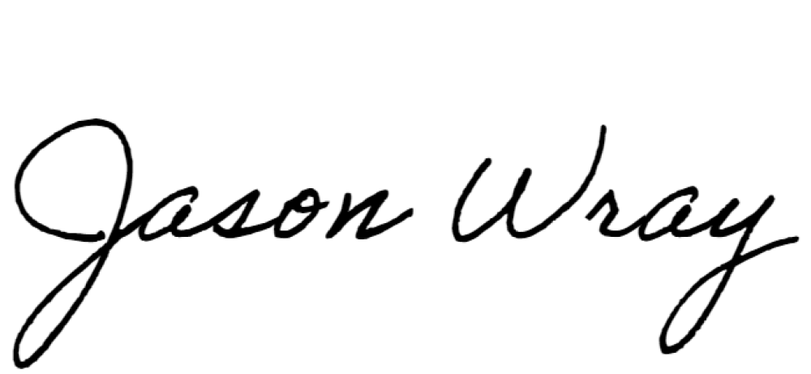
Yours faithfully,

Jason Wray

cc R C Hayhoe
M O’Brien
S Thorpe
P Haugh
D Singh
P Bennett
J Hayhoe

